**Here’s the outlook of the Blog created with Word press.**

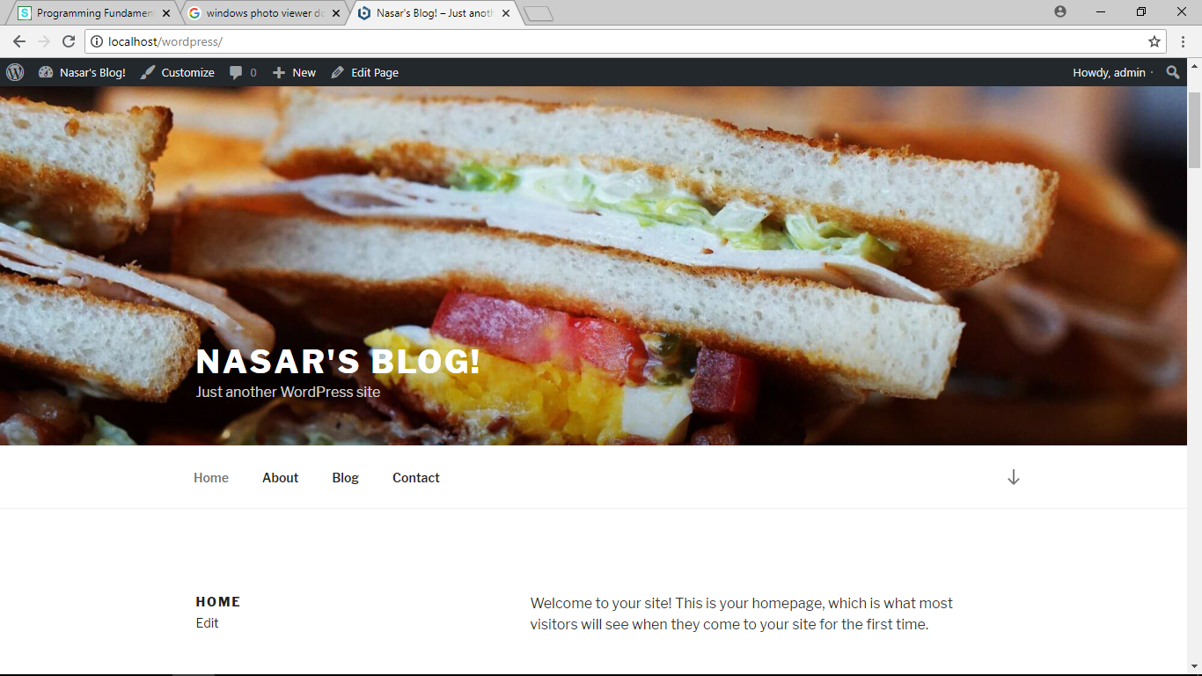

To Post on the blog I First login to my Acc.

Then simply go to Add option and click on Post. Gave the tittle “New Post” And write in the box what I wanted to post.

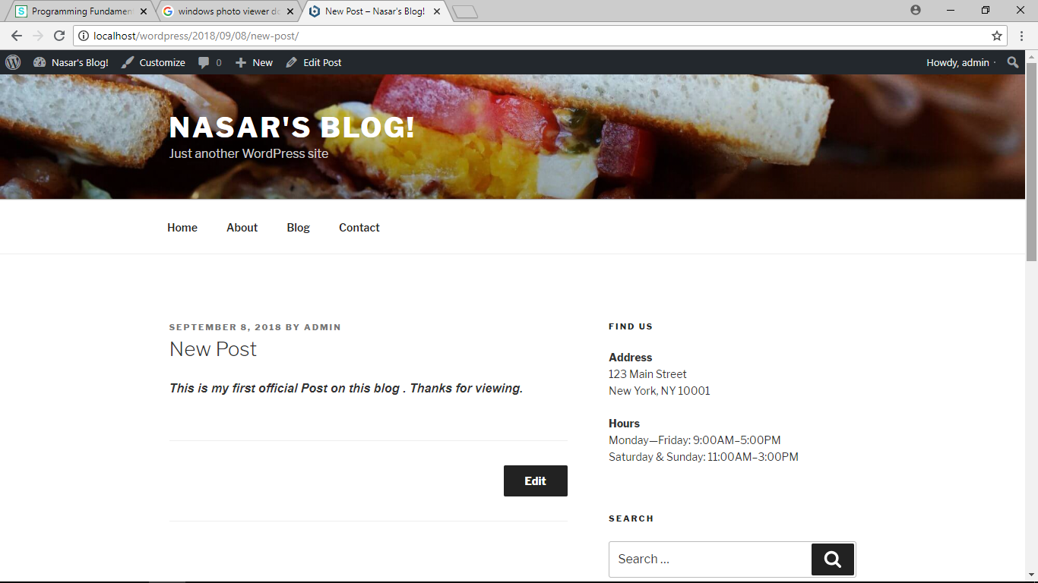 After posting I Viewed the post .

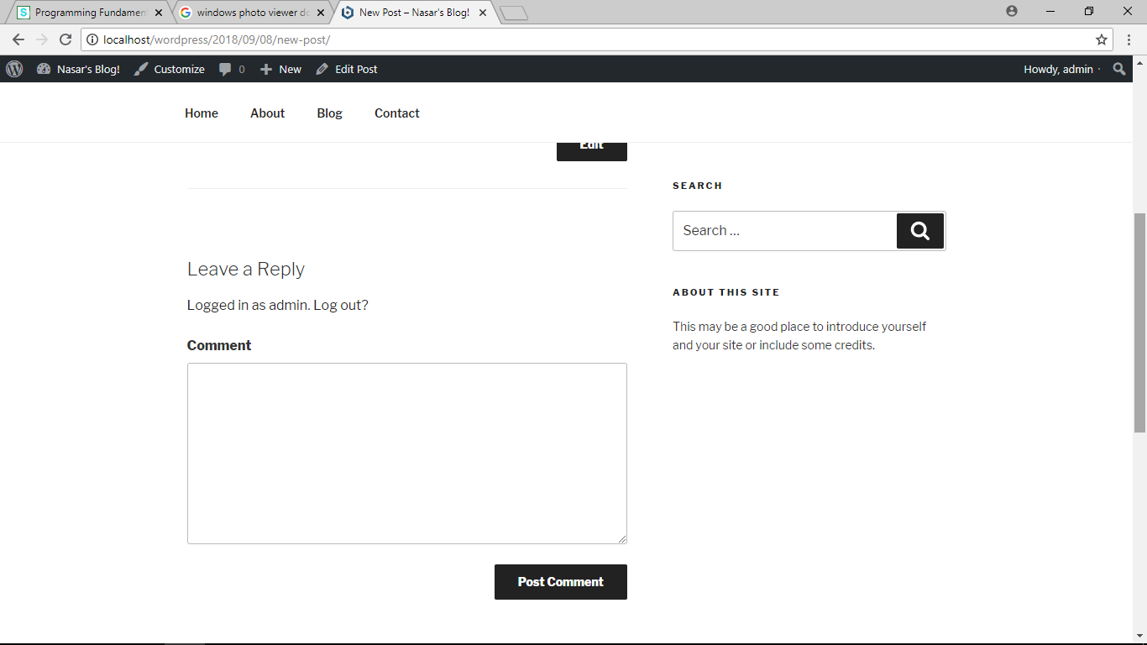 In Comment session wrote the comment I wanted to post on my post. And then simply clicked ***post comment*** button.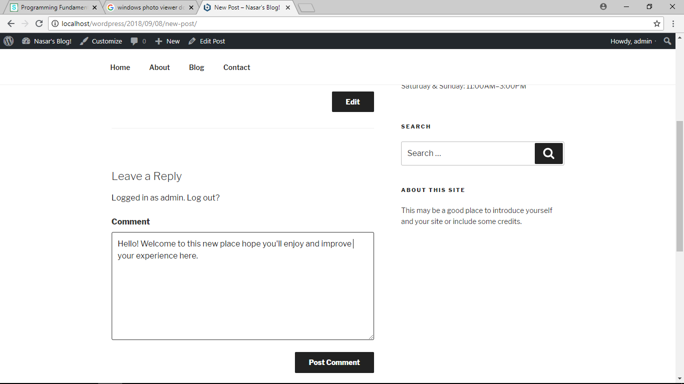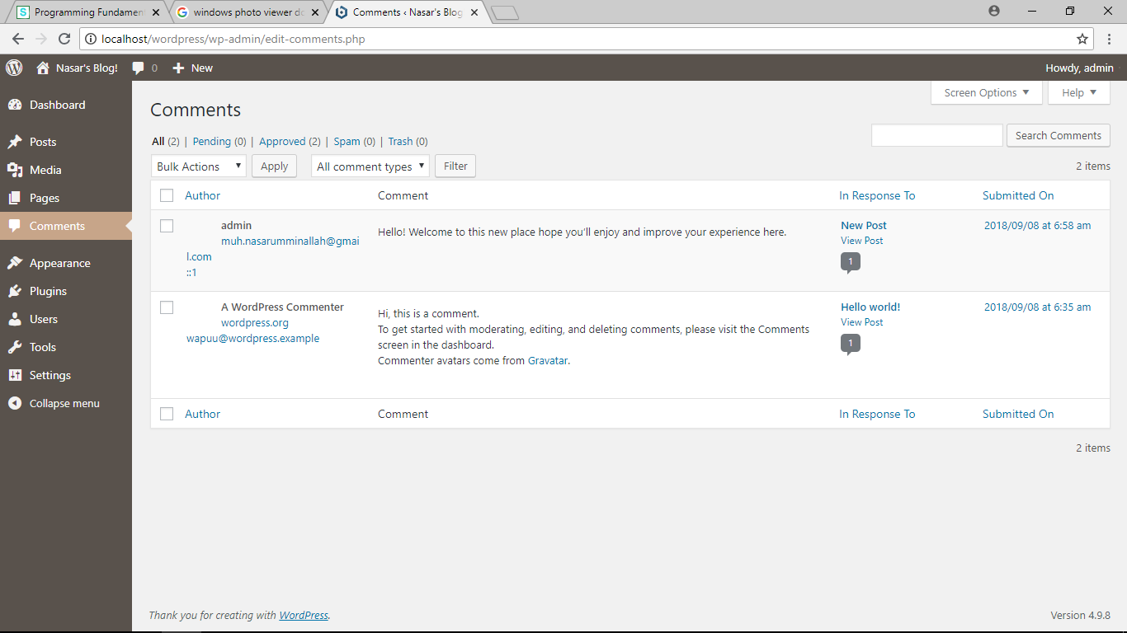To create new page I went to new option and clicked on page button.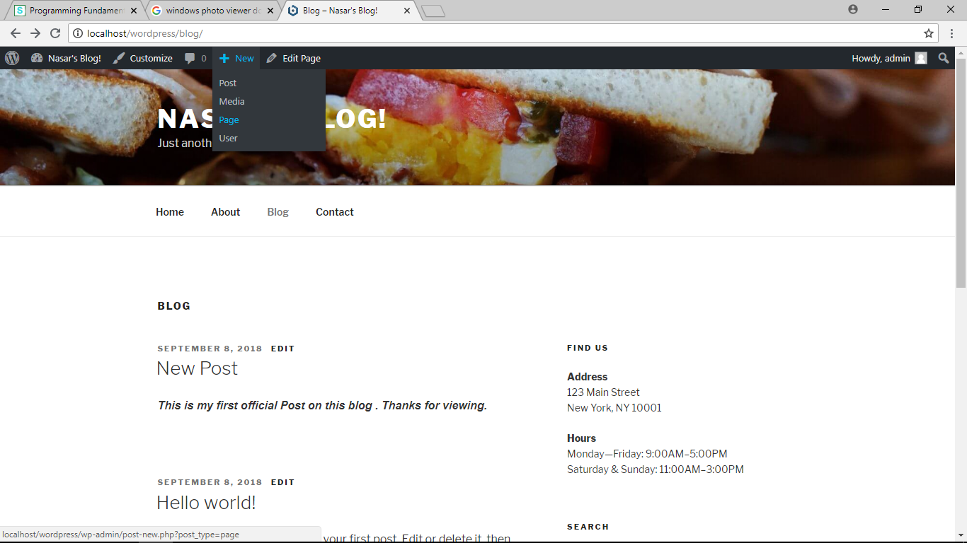In respective boxes wrote the tittle and paragraph. And clicked posted to post it on my vlog.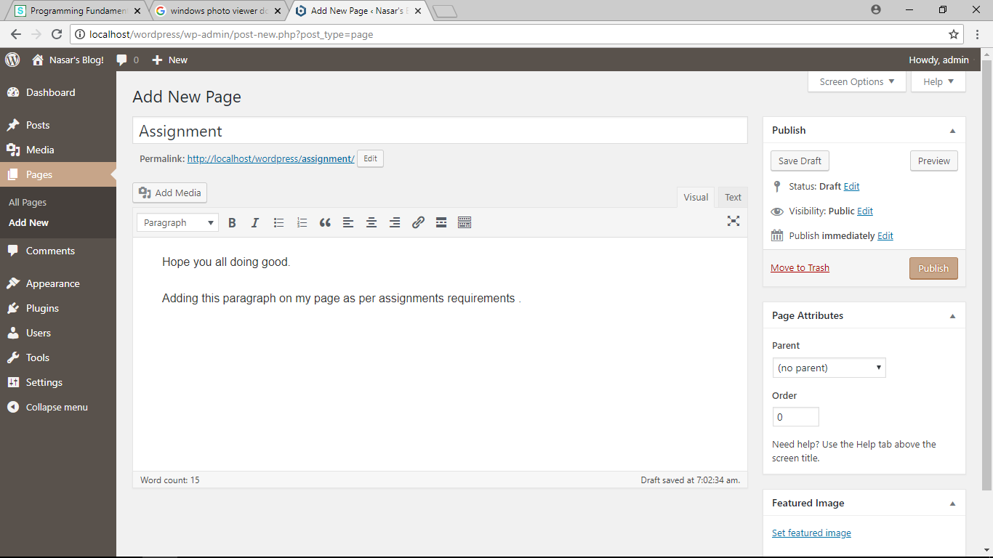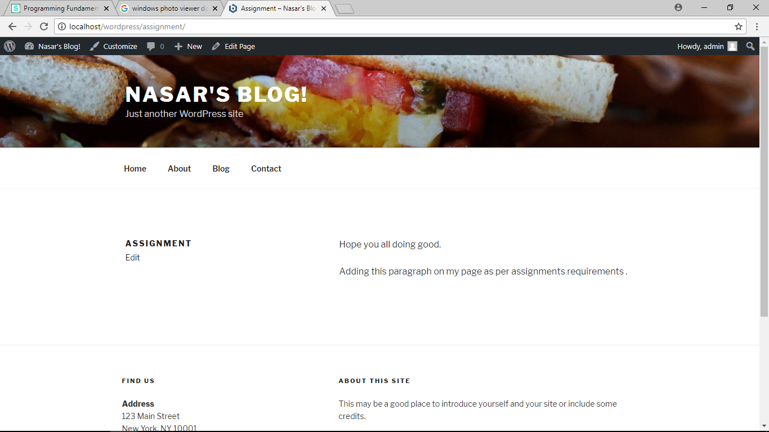

Assignment submitted by : M.Nasar (p18-0086)